**Zaitz Park**

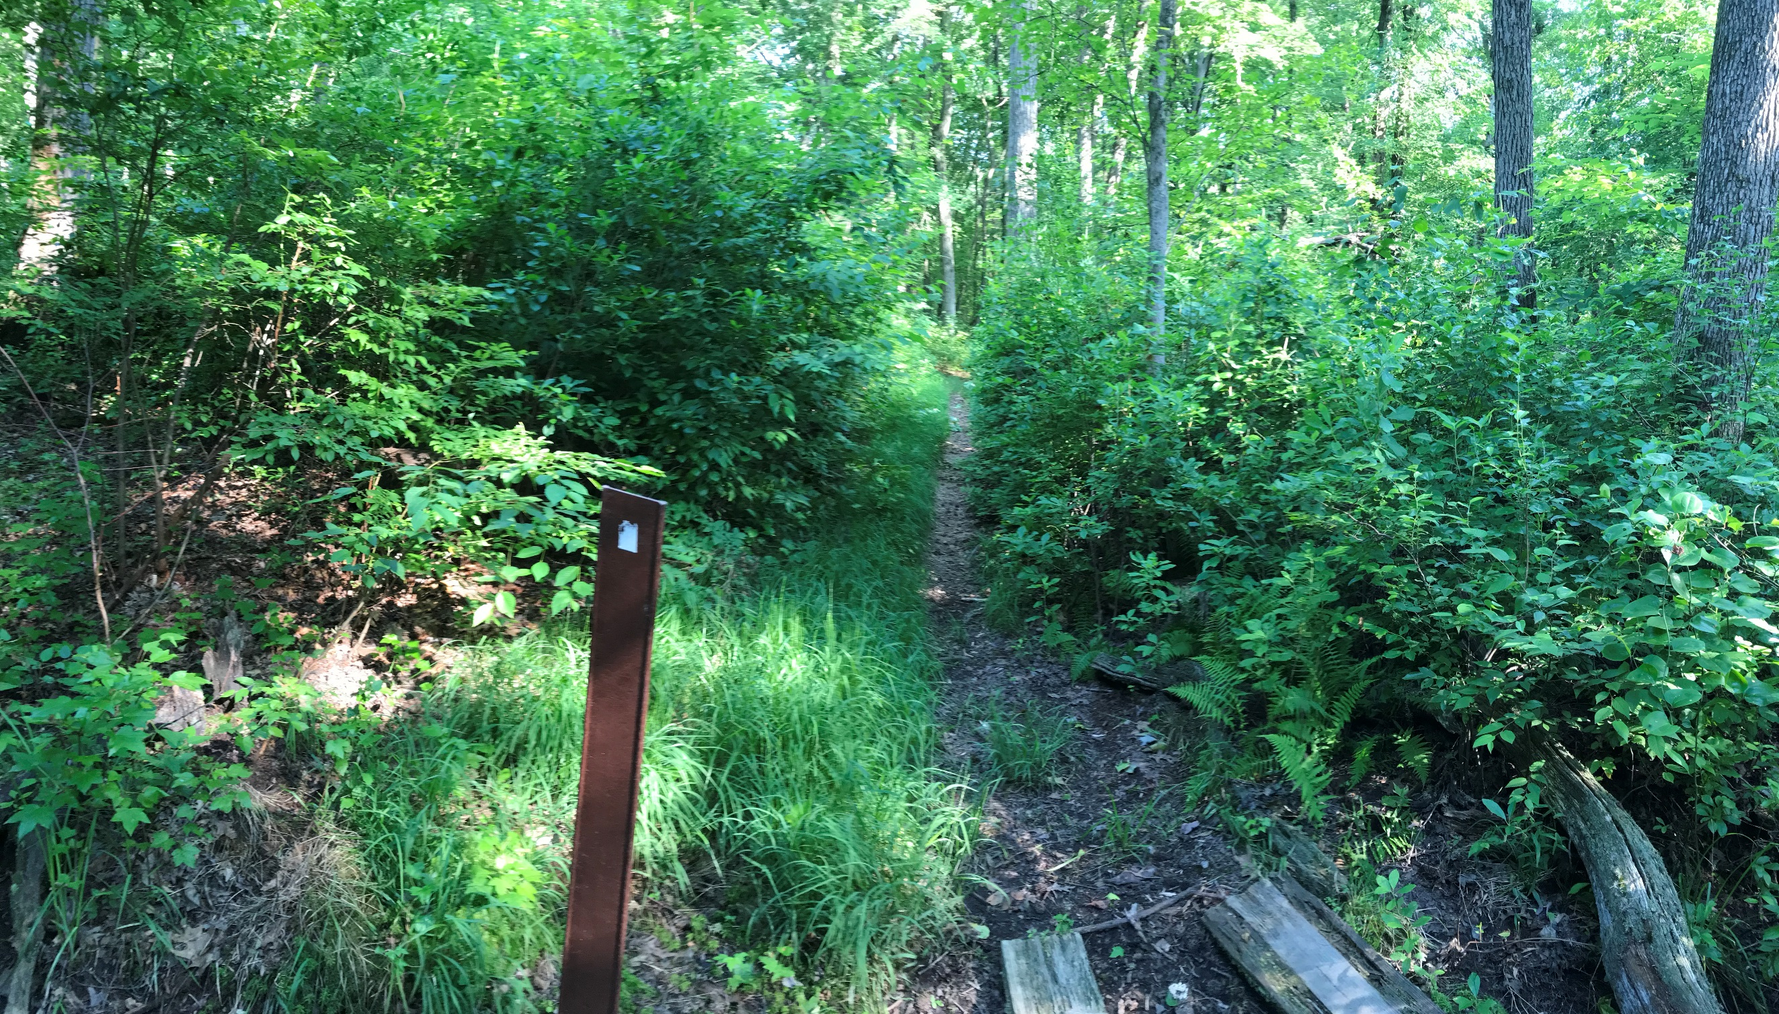

Four recreational soccer fields are utilized by

the West Windsor-Plainsboro Soccer

Association for games and practices at this

site. Walking trails through the Zaitz Nature

Preserve is also located at this site.

**Address:** Zaitz Park, Southfield Rd, West

Windsor Township, NJ 08550

**Girl Scout Silver Award Project for West Windsor Township Website**

West Windsor Township has many unique and

interesting parks. This brochure lists the twelve

parks and their addresses. The following

updated website will provide additional

information about the parks. Such as

additional pictures, the number of facilities

each park offers, and a trail map of certain

parks.

[https://www.westwindsornj.org/par](https://www.westwindsornj.org/parksfacility.html)

[ksfacility.html](https://www.westwindsornj.org/parksfacility.html)

**Trolley Line Trail**

The trail is a paved pedestrian/bike path that extends from Rabbit Hill Road to Penn Lyle Road.

**Van Nest Park**

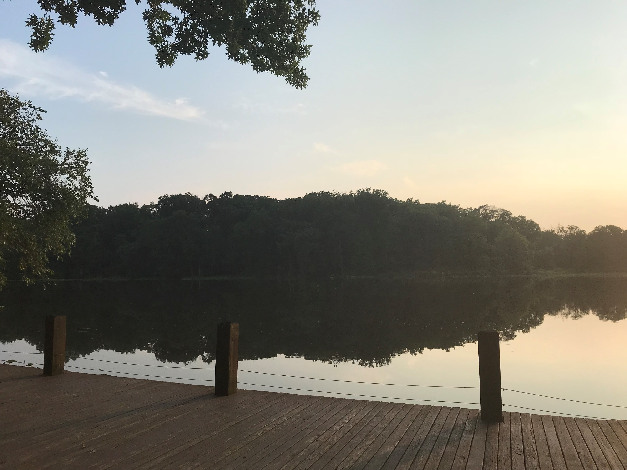

Features of this park include a picnic pavilion, playground equipment, dock and boat launch and open space.

**Address:** Van Nest Park, 218 Cranbury Rd, West Windsor Township, NJ 08550

**West Windsor Community Park**

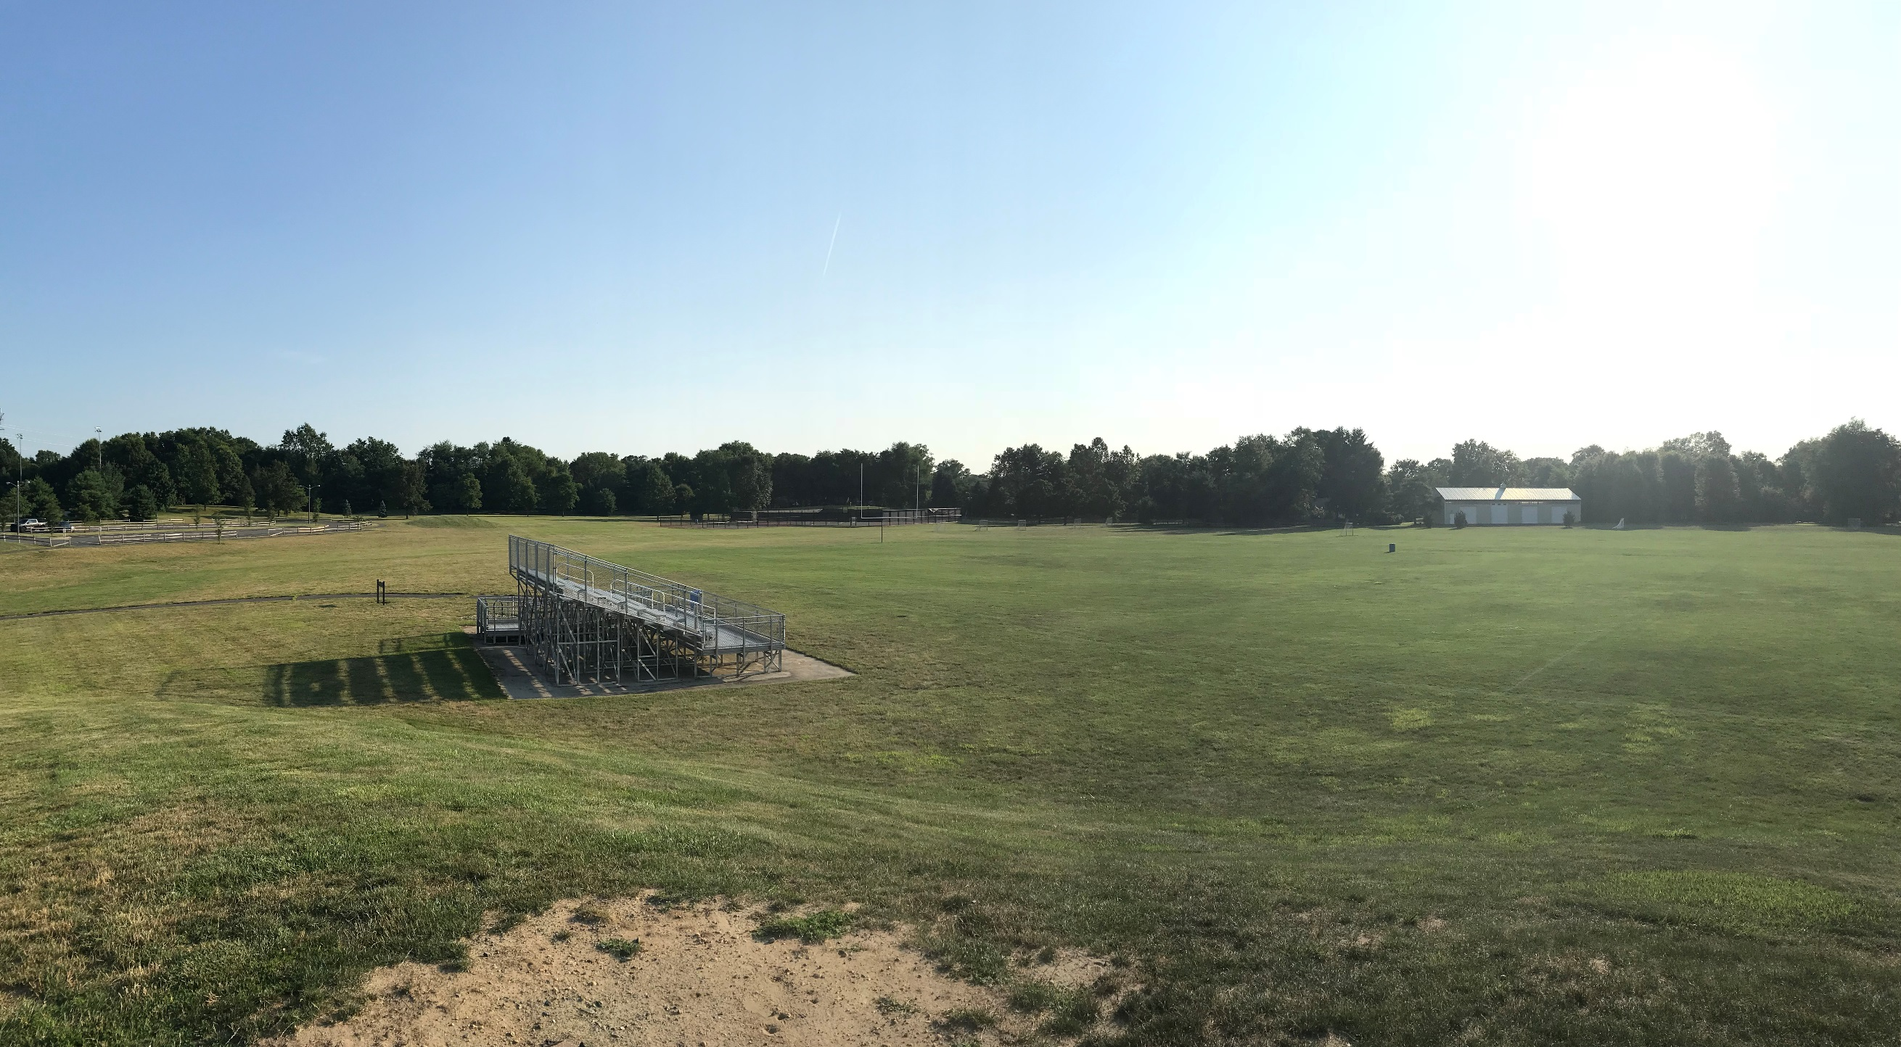

This 123-acre park is the main active recreational facility in the township. The park has many facilities, which includes a pool.

**Address:** West Windsor Community Park, West Windsor Township, NJ 08550

West Windsor Township Parks



**By**

**Emily Liu**

**Hendrickson Tennis Drive Complex**

This complex has five lighted tennis courts, a playground and a practice wall.

**Address:** Tennis Courts, 199 Hendrickson Dr, West Windsor Township, NJ 08550

**Lewis B. Chamberlin Park**

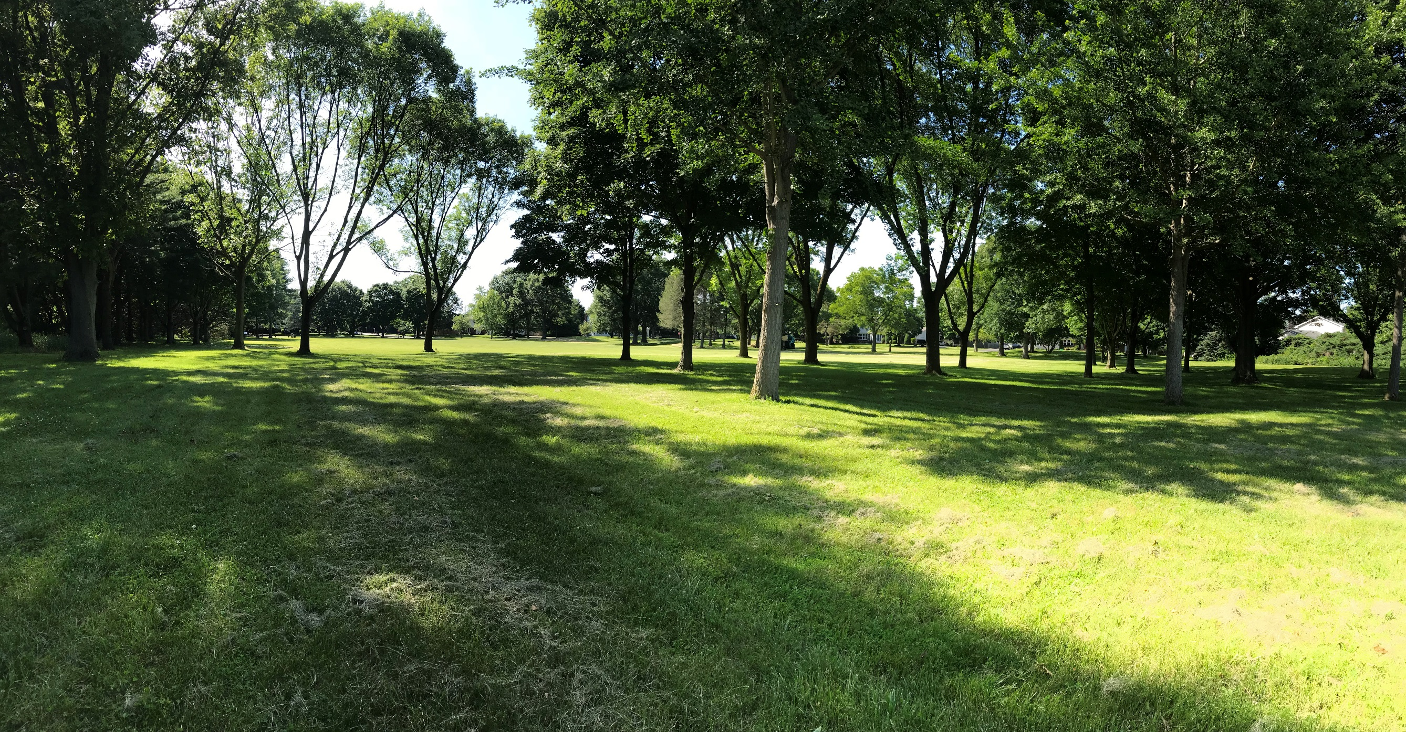

This neighborhood park has a big field for various activities and a playground.

**Address:** Lewis B. Chamberlin Park, 53 Slayback Dr, West Windsor Township, NJ 08550

**Millstone River Preserve**

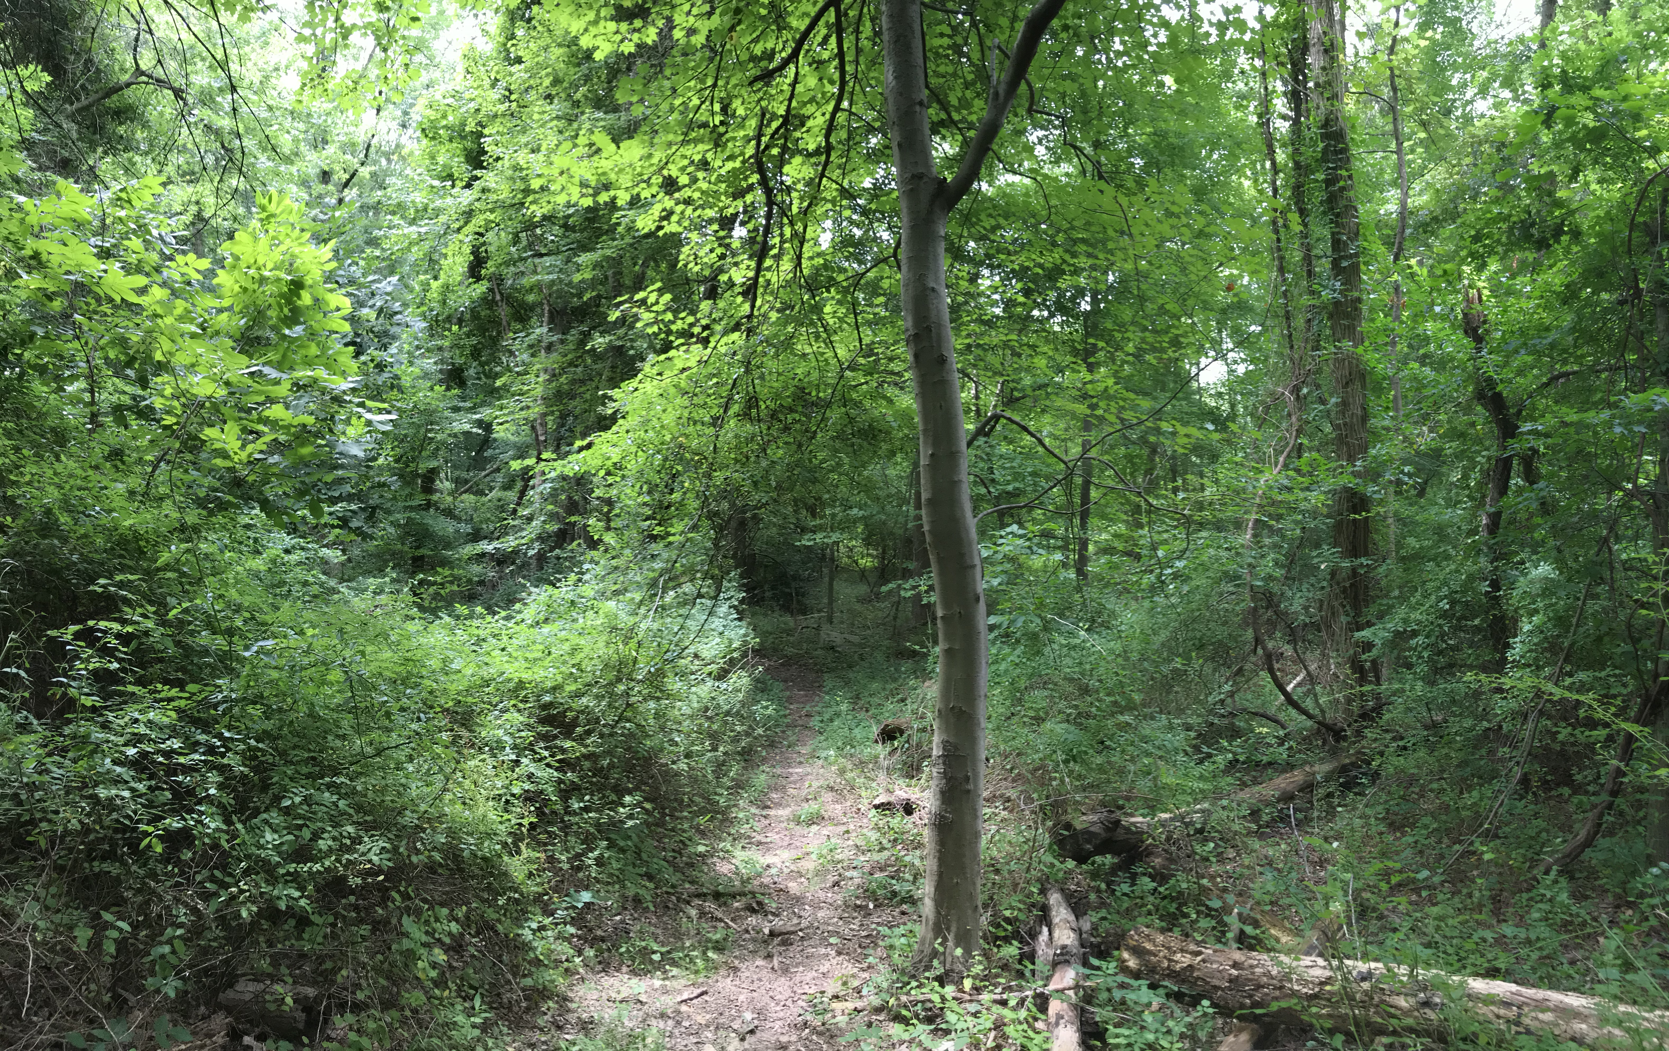

The Preserve has several walking/hiking trails. Trails traverse through varied habitat: upland oak forest, wetlands/floodplain.

**Address:** 34 Millstone Rd, Princeton Junction, NJ 08550

**Rogers Preserve**

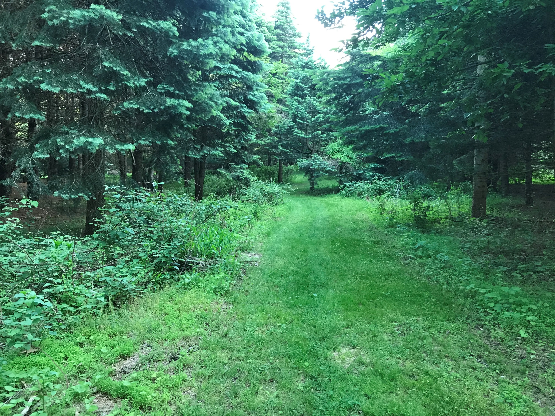

The Preserve has two walking/hiking trails. The trails traverse through varied habitat – an old tree nursery, upland oak forest; and wetlands/floodplain along Big Bear Brook.

**Address:** Rogers Preserve/Millstone River Preserve, Princeton Junction, NJ 08550

**Ron Rogers Arboretum**

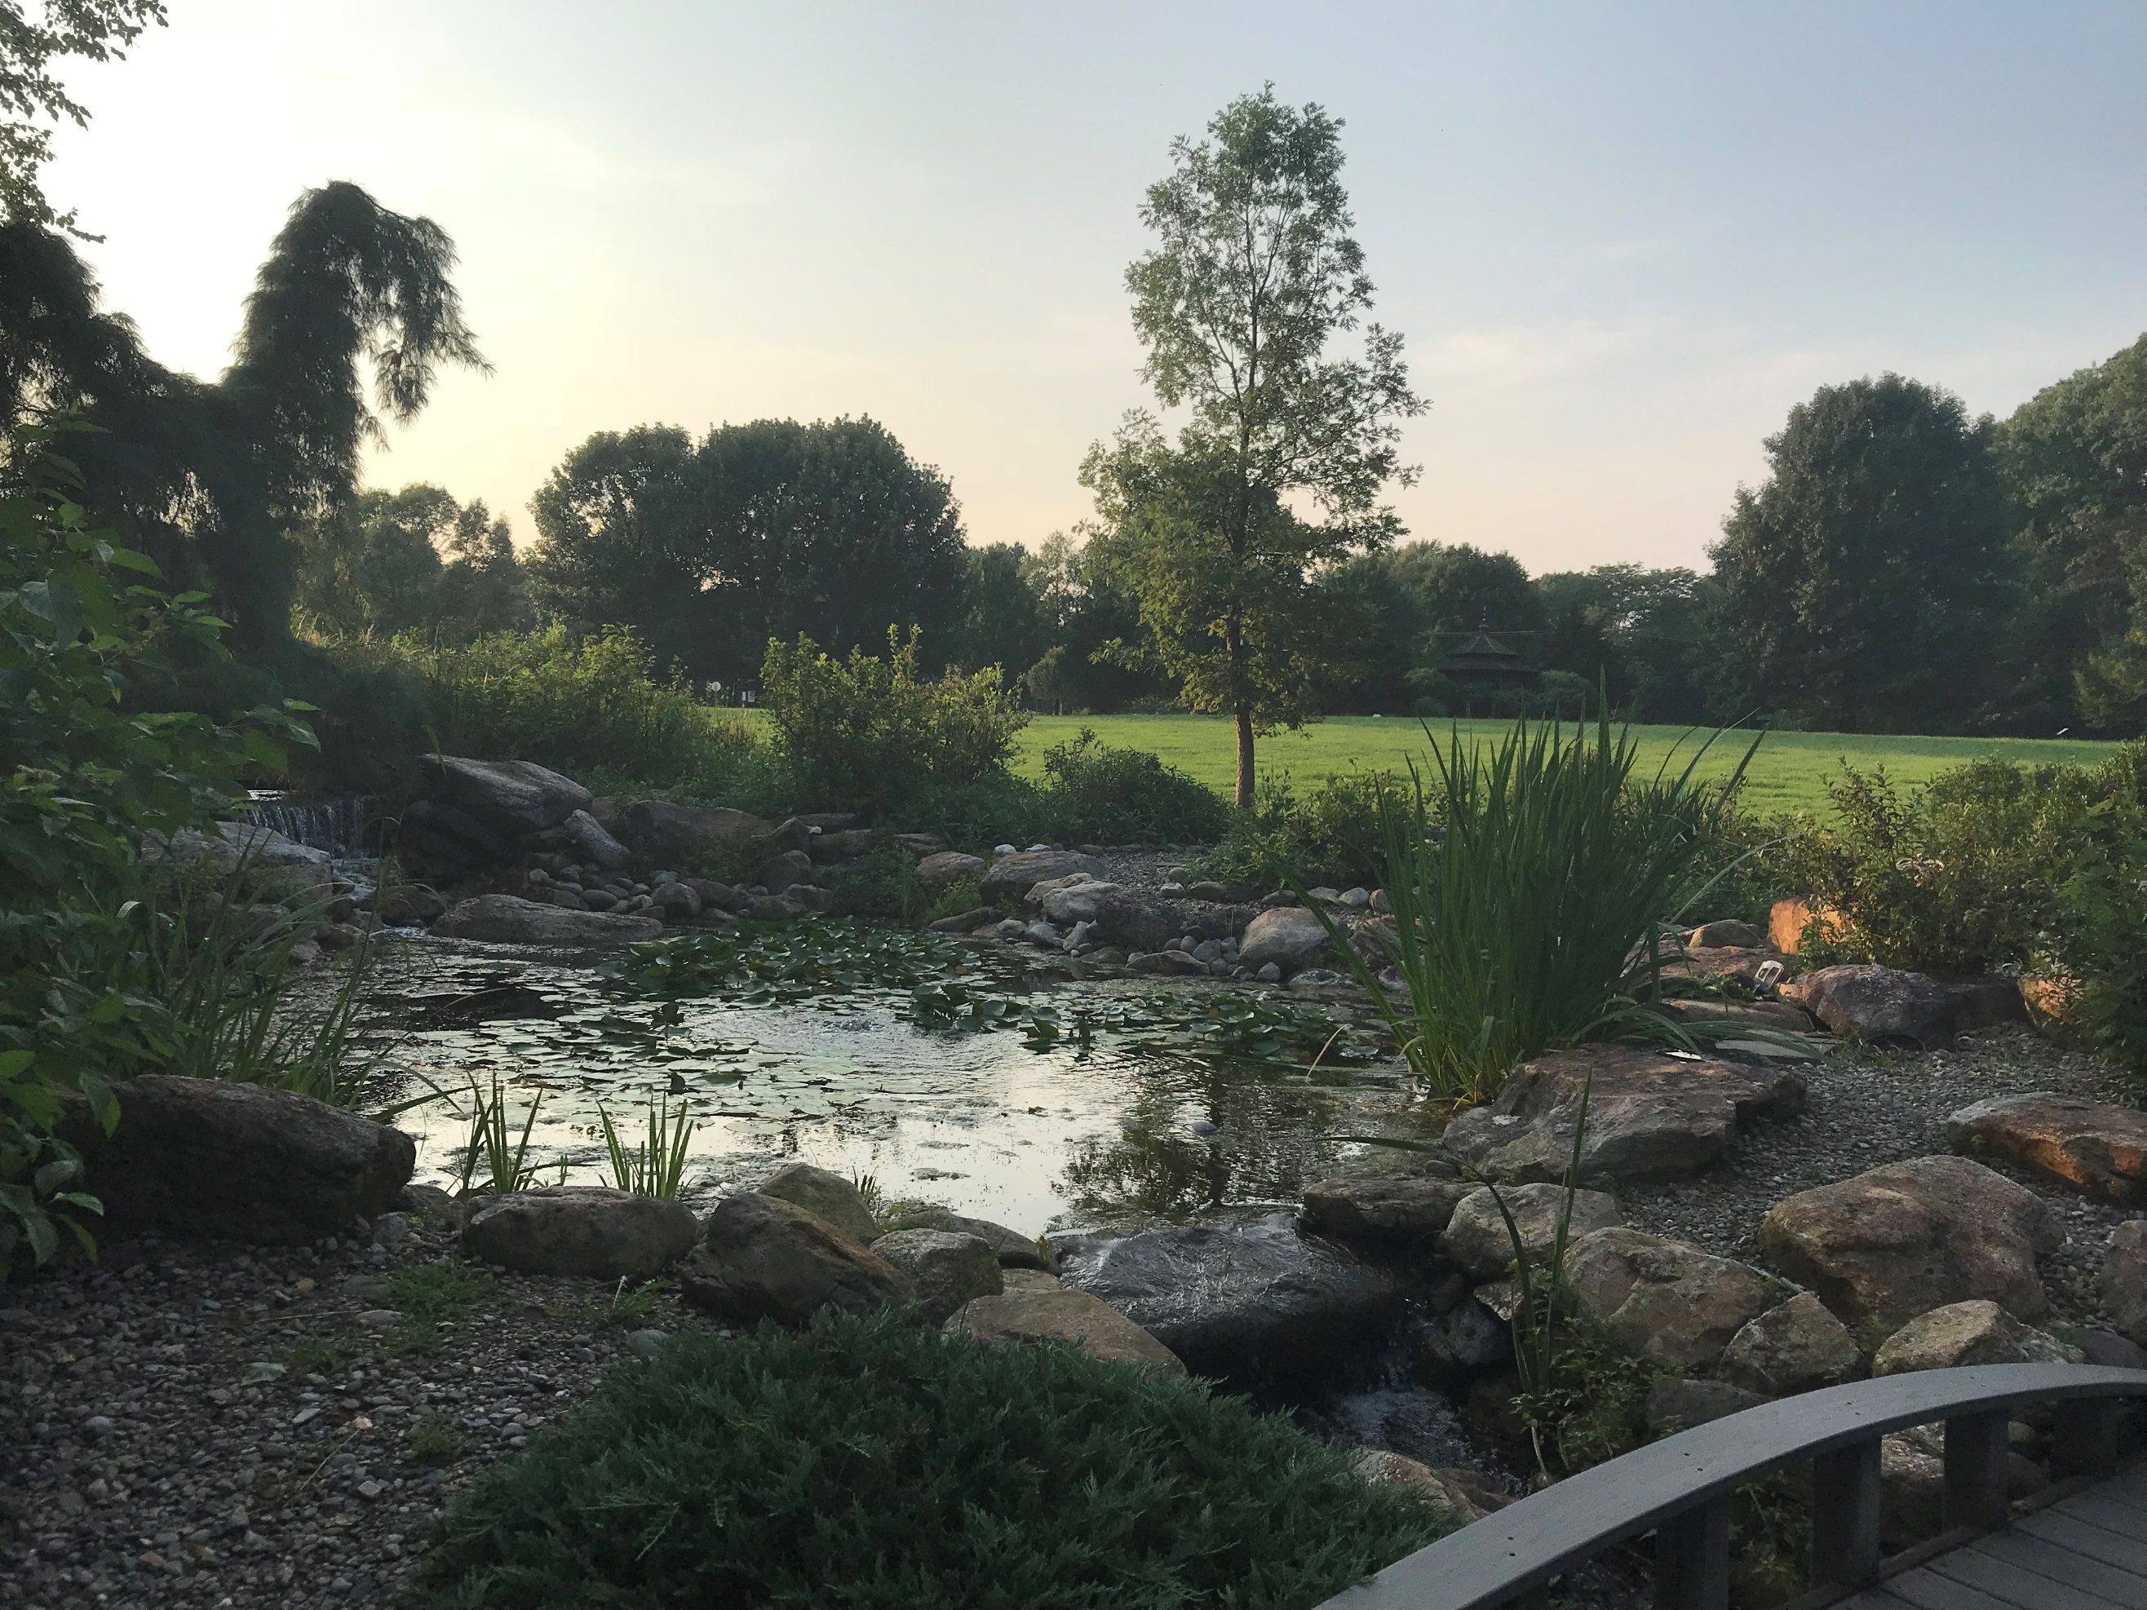

The site of the arboretum is a 25-acre parcel of land that consists of approximately 12 acres of open field and 13 acres of mature woodland. The arboretum is also the site of the September 11 memorial.

**Address:** Ronald R. Rogers Arboretum, Clarksville Rd, West Windsor Township, NJ 08550

**Conover Field**

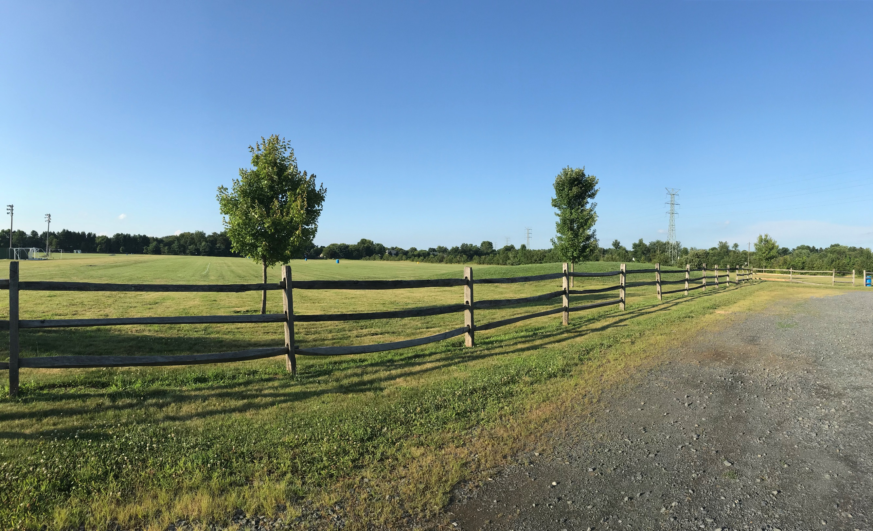

This site includes various sports fields including five soccer fields, five baseball fields and one softball field.

**Address:** Conover Field, 98 N Post Rd, West Windsor Township, NJ 08550

**Dey Forest Park**

Planted with many pine trees, this park is named in tribute to Larry and Lollie Dey, who once farmed this and surrounding property.

**Address:** Carlton Pl, Princeton Junction, NJ 08550

**Duck Pond Park**

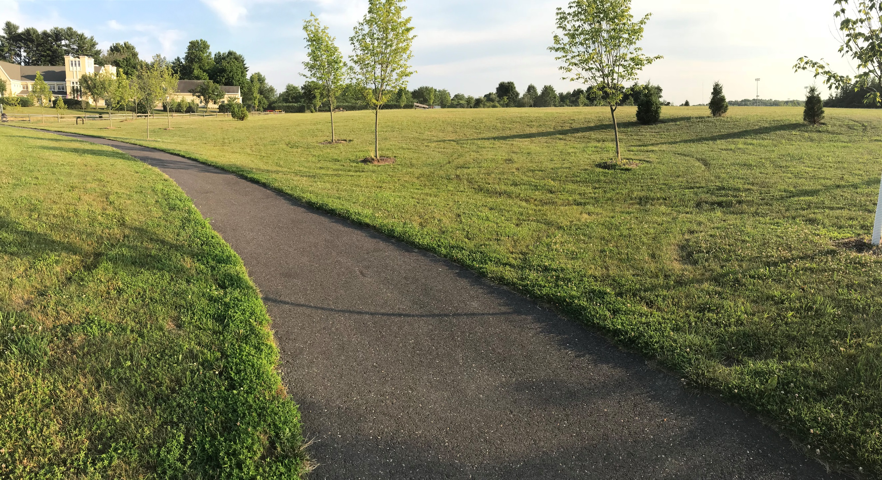

This Park includes over 120 acres that is approximately 60 acres of nature preserve and 60 acres of active recreation.

**Address:** 560 Meadow Rd, Princeton, NJ 08540